**A MINI PROJECT REPORT**

**ON**

**“Rainfall Prediction And Water Quality”**

Submitted to

SAVITRIBAI PHULE PUNE UNIVERSITY

in completion of

**SKILL DEVELOPMENT LABORATORY**

**(T.E Computer Engineering)**

**BY**

Ashilesh Sonkusle Exam No :

Shubham Andhale Exam No :

Shrikant Kurhe Exam No :

Rishabh Kotecha Exam No :



Department of Computer Engineering

Sinhgad College of Engineering, Pune-41

**Accredited by NAAC with grade ‘A’**

**YEAR 2019-20**

CERTIFICATE



Sinhgad Technical Education Society,

Department of Computer Engineering

Sinhgad College of Engineering, Pune-41

**Accredited by NAAC with grade ‘A’**

**“Rainfall Prediction and Water Quality”**

Submitted to

SAVITRIBAI PHULE PUNE UNIVERSITY

in completion of

**SKILL DEVELOPMENT LABORATORY**

**(T.E Computer Engineering)**

BY

Ashilesh Sonkusle Exam No :

Shubham Andhale Exam No :

Shrikant Kurhe Exam No :

Rishabh Kotecha Exam No :

Prof. G.G.Chiddarwar Prof. M. P. Wankhade

Internal Guide Head of Dept.

Department of Computer Engineering Department of Computer Engineering

Dr. S.D. Lokhande

Principal

SCOE, Pune

**CONTENTS**

# TITLE PAGE NO

# 

Certificate 2

Acknowledgement 4

Abstract 5

List of Figures 6

Introduction 7

Project planning & management 8

Analysis & design 9-10

Implementation & coding 11-16

Conclusion 17

Reference 17

**ACKNOWLEDGEMENT**

“Gratitude is not only the greatest of virtues, but the parent of all others.”

Hence, it is great pleasure for us to acknowledge the assistance and contribution of number of individuals who helped our team in developing “**Rainfall Prediction And Water Quality**” project. First and Foremost we wish to record our gratitude and thanks to **Prof. G.G.Chiddarwar** for her enthusiastic guidance and help us in successful completion of seminar.We express our thanks to **Prof. S.D.Lokhande** (Principal), **Prof. M.P.Wankhade** (Head of Computer Department) and **Prof. G.G.Chiddarwar** (Project Co-coordinator) for their valuable guidance. We are also thankful to other teachers and non-teaching staff of Computer Engineering Department and Library for their co-operation and helping us and guiding us to complete our project accurately.

**ABSTRACT**

The prediction of rainfall helps in understanding the overall condition of our environment

And act accordingly .The prediction gives us idea about the upcoming rainfall measure so that we can be ready for water management. Water Quality shows us the condition of water. This

Helps in spreading awareness about the importance of water in our daily life.

In this project Support Linear Regression Algorithm is used. **Linear Regression** is a machine learning algorithm based on **supervised learning**. It performs a **regression task**. Regression models a target prediction value based on independent variables. It is mostly used for finding out the relationship between variables and forecasting. Different regression models differ based on – the kind of relationship between dependent and independent variables, they are considering and the number of independent variables being used. Rainfall prediction becomes easy due to this algorithm.

India is an agricultural country and most of economy of India depends upon the agriculture. Rainfall plays an important role in agriculture so early prediction of rainfall is necessary for the better economic growth of our country. Rainfall prediction has been the one of the most challenging issue around the world in last year. Widely used techniques for prediction are Regression analysis, clustering, and Artificial Neural Network (ANN) etc. This paper represents a review of different rainfall prediction techniques for the early prediction of rainfall prediction of rainfall.

**LIST OF FIGURES**

1. Process Model.
2. Use Case Diagram
3. Gui Interface
4. Rainfall Prediction
5. Graph of rainfall over the years
6. Statewise rainfall
7. Conductivity graph
8. Pie Chart
9. Temperature Graph
10. **INTRODUCTION** 
    1. **Background And Basics**

India receives 80% of its annual rainfall during the southwest monsoon season of june to September. Rainfall over the country during this season shows a wind range of spatial variation due to orographic influences and preferential occurrence of rain

system in certain regions. Source of all water on earth is not the river, is not the underground aquifer, is not the lake, well or stream. Rain is the source of all water.

Agriculture is the backbone of Indian economy. Irrigation facility is still not so good in India and most of agriculture depends upon the rain. A good rainfall result in the occurrence of a dry period for a long time or heavy rain both affect the crop yield as well as the economy of country, so due to that early prediction of rainfall is very crucial . A wide range of rainfall forecast methods are employed in weather prediction at regional and national levels. Fundamentally there are two approaches to predict Rainfall.

Water quality describes the condition of the water, including chemical, physical, and biological characteristics.

Poor water quality can pose a health risk for ecosystems.

* 1. **Problem Statement**

Crisis of Water likes floods due to over rainfall or droughts due to extremely low rainfall need to solved. So rainfall prediction plays a vital role in understating the behavior of rain.

Create a Web Application which predicts rainfall over an year month wise.

Water Quality should also be understood by an individual inorder to preserve environment.

Add different Water Quality Graphs in the same Web Application.

**2**. **PROJECT PLANNING & MANAGEMENT**

**2.1 Software requirement**

**2.1.1 Python**

**Python** is an interpreted, high-level, general-purpose , programming language . Created by Guido van Rossum  and first released in 1991, Python's design philosophy emphasizes code readability with its notable use of significant whitespace. Its language constructs and object-oriented approach aim to help programmers write clear, logical code for small and large-scale projects.

Python is dynamically typed and garbage-collected. It supports multiple programming paradigms, including procedural, object-oriented, and functional programming. Python is often described as a "batteries included" language due to its comprehensive standard library

.

**2.1.4. Machine Learning Algorithm.**

**Machine learning** (**ML**) is the  scientific study of algorithms and statistical models that computer systems use to perform a specific task without using explicit instructions, relying on patterns and inference instead. It is seen as a subset of artificial intelligence. Machine learning algorithms build a mathematical model based on sample data, known as "training data", in order to make predictions or decisions without being explicitly programmed to perform the task. Machine learning algorithms are used in a wide variety of applications, such as email filtering and computer vision, where it is difficult or infeasible to develop a conventional algorithm for effectively performing the task.

**2.1 Process Model**

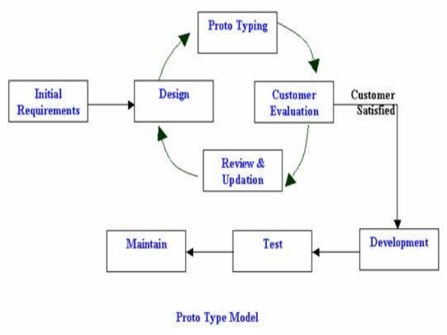

**3. ANALYSIS & DESIGN**

**3.1 Use-Case Diagrams**

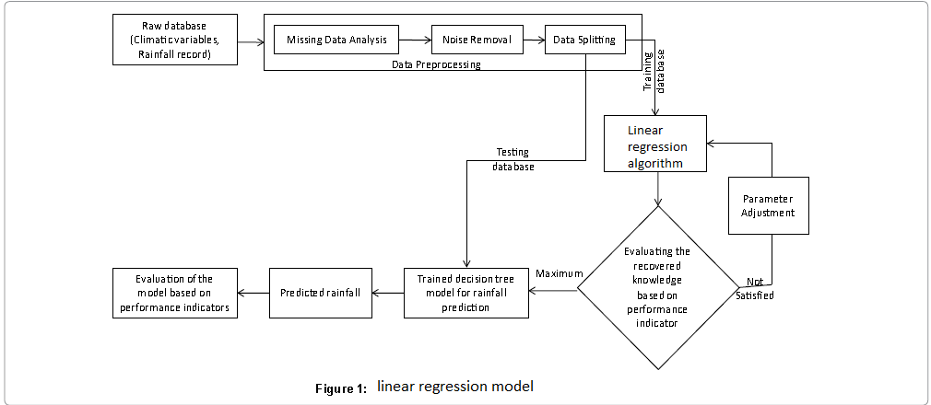

**3.2 State Transition Diagrams**

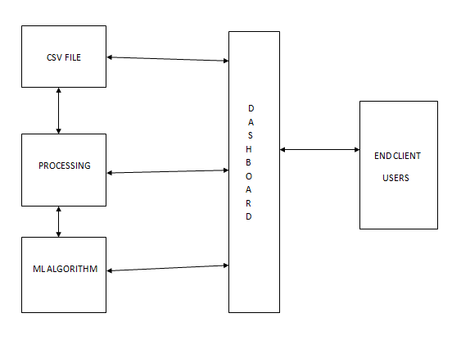

**4. IMPLEMENTION & CODING**

**4.1 Methodology**

We did the quantitative research by visiting various websites.

We collected our Dataset from Kaggle.com and did the code survey from and StackOverflow websites.

Before analysis the gathered data was prepared. The dataset was checked for missing data and outliers.

* 1. **Algorithms**

1. Start
2. Open Command Prompt
3. Type Command “python manage.py runserver” and press Enter
4. Once you get an url- <http://127.0.0.1.800>0 copy the url in browser. Dashboard will appear.
5. Choose the required year from 1901 to 2018 from the slider.
6. View different graphs on water quality and select state from map to view respective state rainfall.
7. End.

**4.3 Flowchart**

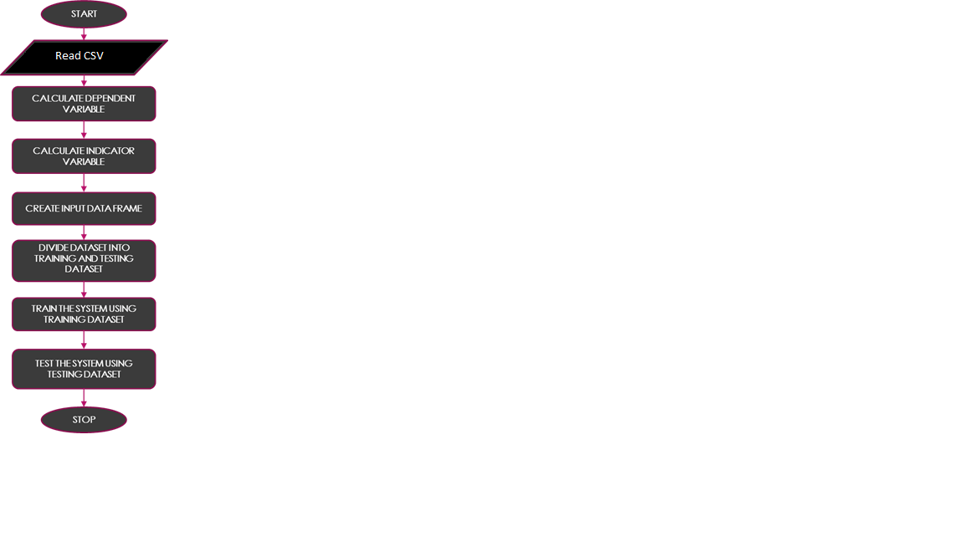

* 1. **GUI Design /screen shots**

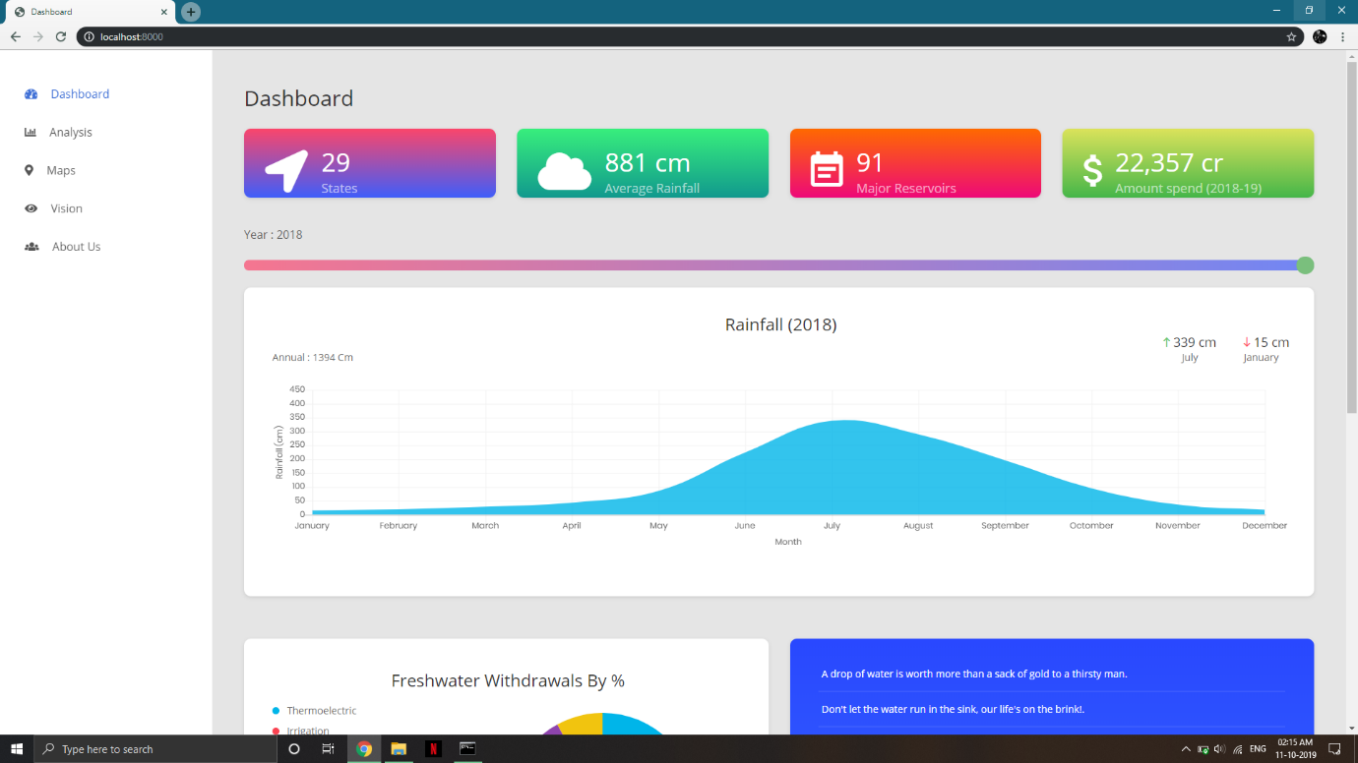

Fig (1) : GUI Interface.

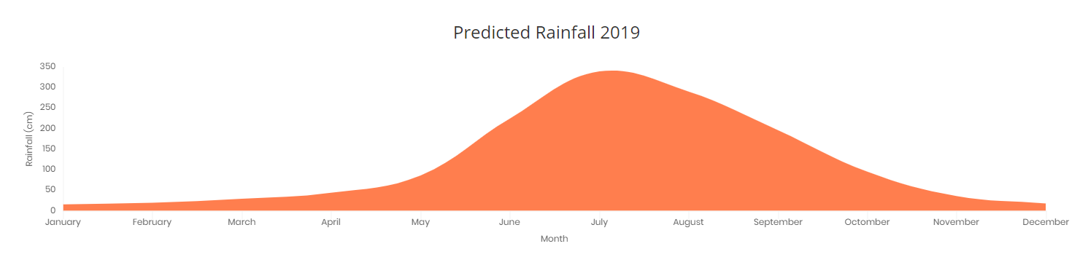

Fig (2) : Prediction graph.

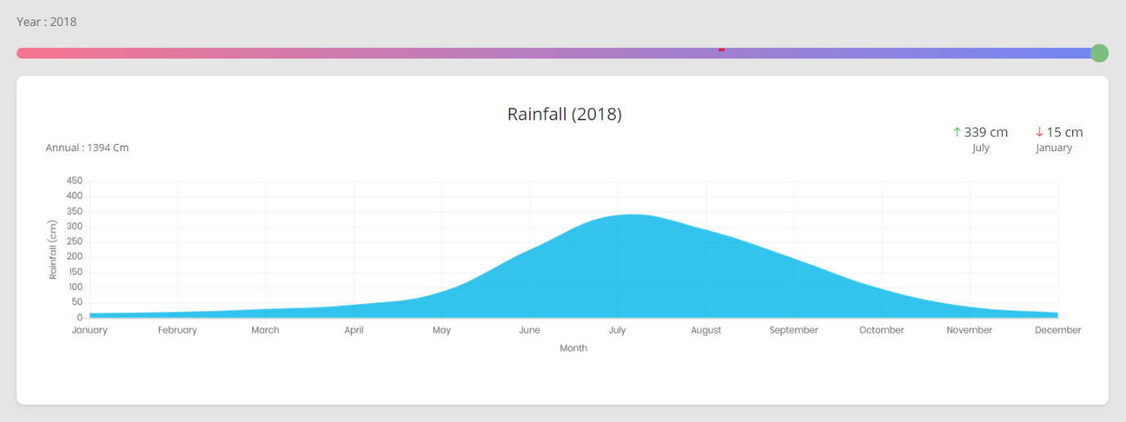

Fig (3) : The graphs over the years.

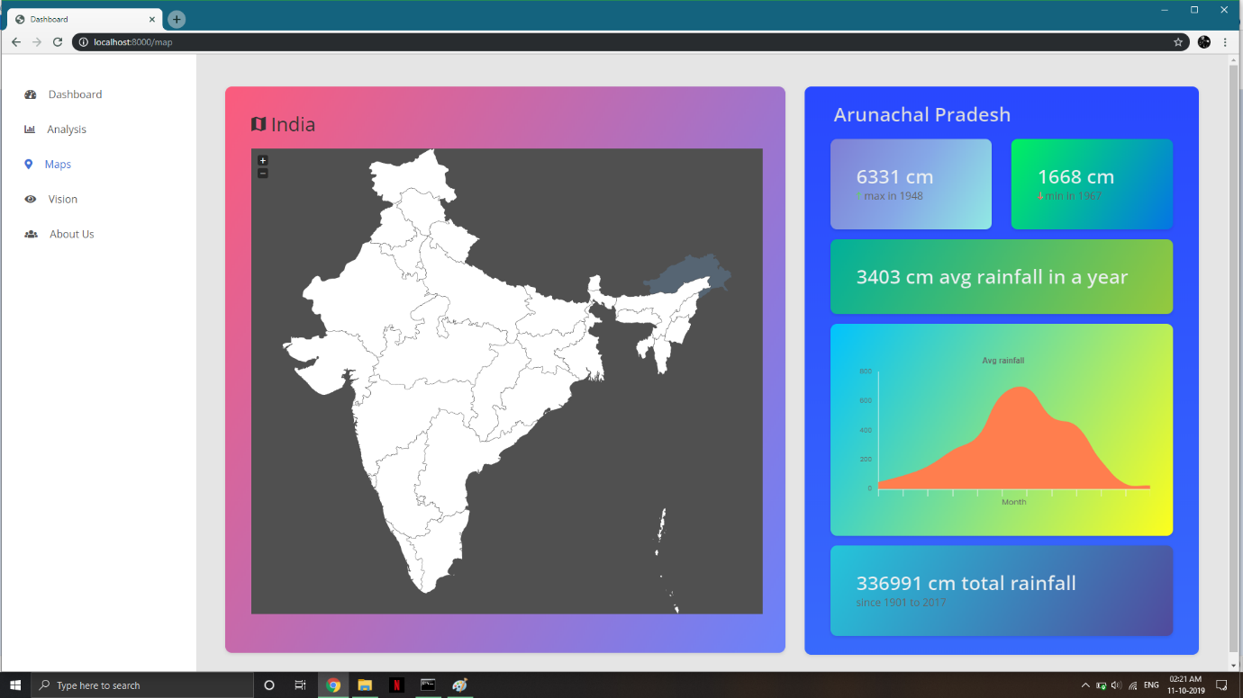

Fig (4) : Graph of rainfall of various states from map.

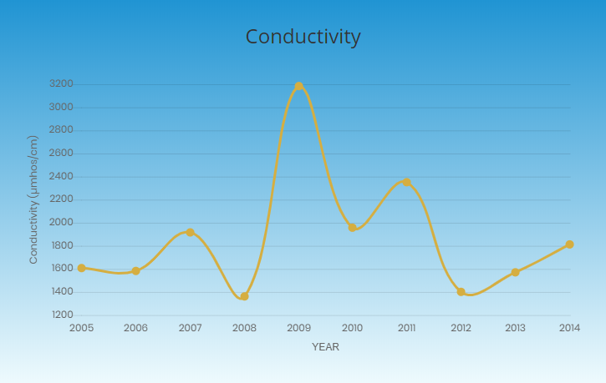

Fig (5) : Graph of conductivity of water.

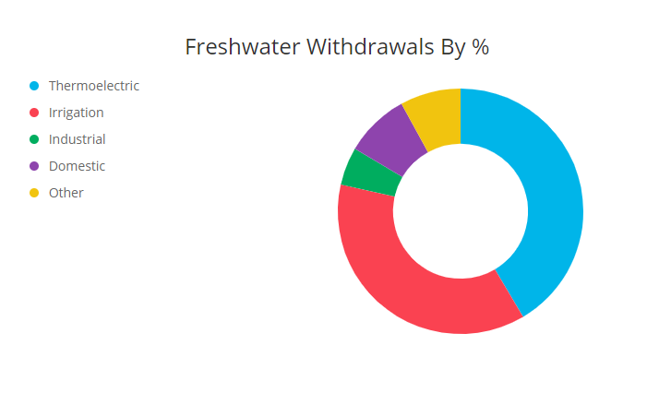

Fig (6) : Pie Chart.

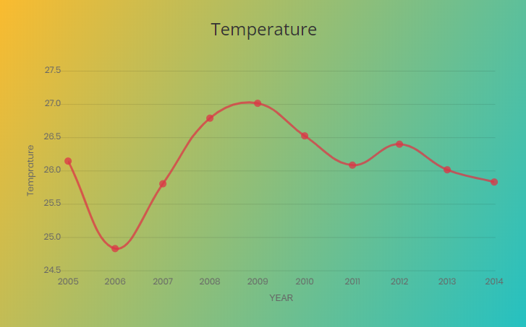

Fig(7): Temperature graph.

**5. CONCLUSION**

The purpose of the project was to establish that the prediction of rainfall. This helps in understanding of future rain measurement.

We got with the help of machine learning .

**6. REFERENCES**

**1.**[**https://www.kaggle.com**](https://www.kaggle.com)

**2.**[**https://plot.ly**](https://plot.ly)

**3.**[**https://community.plot.ly**](https://community.plot.ly)

**4.**[**https://github.com**](https://github.com)

**5.**[**https://www.w3schools.com**](https://www.w3schools.com)

**6.**[**https://stackoverflow.com**](https://stackoverflow.com)